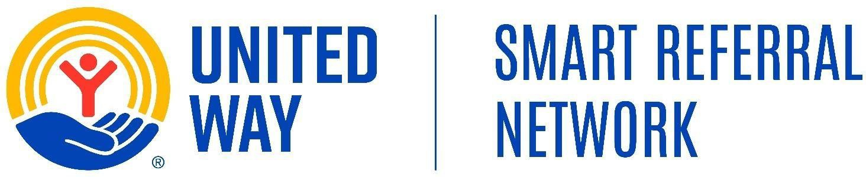

SRN-Kings/Tulare Alliance Meeting

Date: Thursday, September 17, 2026
Time: 1:30 PM – 2:30 PM
Location: Click Here to Join Meeting

1:30 PM – 1:35 PM | Welcome & County Updates.

- Tulare County SRN Updates: Fedieson Landicho, SRN Coordinator.
- Kings County SRN Updates: Maria Valdez, SRN Coordinator.

1:35 PM –1:50 PM | Agency Spotlight: Kings United Way
- Presenter: John Adams (Resource Development Coordinator)
- Topic: Learn how becoming a financial sponsor can help support community programs, local events, and services that benefit individuals and families in need. Discover ways your organization can make a meaningful contribution to the community through financial support and partnership opportunities.

1:50 PM – 2:28 PM | SRN Community Partner Panel – Referral Workflow & Partner Experience
- Programs: 211 Kings County & KCAO Childcare Assistance program
- Topic: Hear directly from two SRN community partners about their experience using the Smart Referral Network (SRN) to send referrals for clients they serve. Panelists will walk through their referral workflow, including creating and sending referrals, following up with clients, and updating referral statuses. They will also share how using SRN has supported their referral process and coordination with service providers.
- Questions are welcome from all partners participating in the call.

2:28 PM- 2:30 PM | Closing
- Community Round Table
- Thank you for attending.

